**CASE STUDY – 4**

Observation: MongoDB for High Write and Read Loads with Real-Time Analytics.

Challenge 1: High Write Loads:

Solution: To handle High Write Lodes in mongoDB we can multiple replica sets and perform write operations on Primary node. Changes which happened on Primary node will get updated to the all Secondary node within time interwall. We cannot perform write operations for Secondary node.

Challenge 2: Low-Latency Reading

Solution: We can achieve Low-Latency Reading by replication only but here we need to do only read operations from both primary and secondary nodes. We can deploy secondary node on region where the are high read requests to handle Low latency.

Challenge 3: Data Consistency

Solution: We can achieve data consistency using Shading feature.

O/P:

Create data directory in C drive and add three sub directories into it.







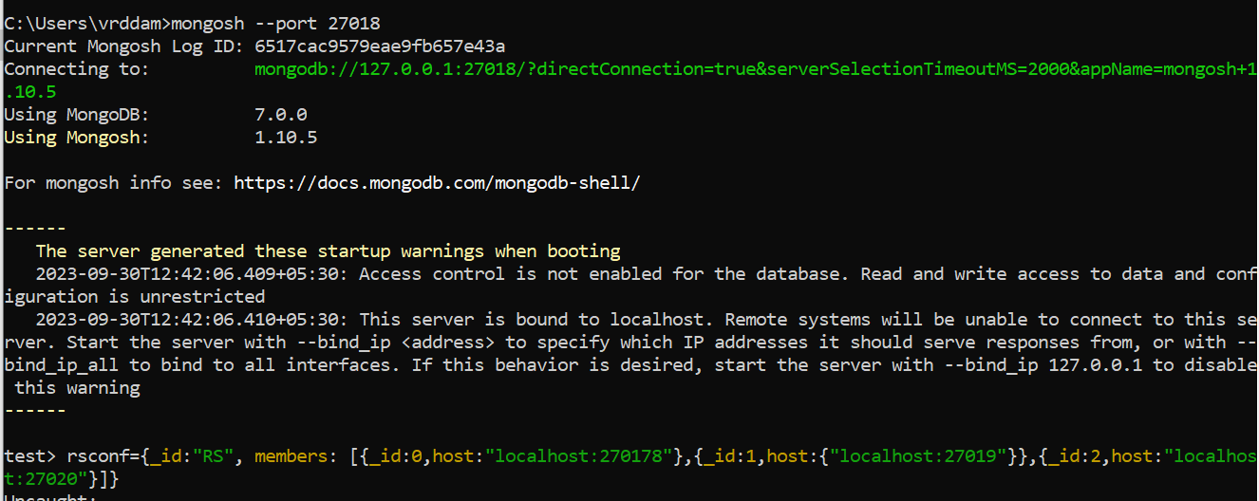

rs.initiate(rsconf);

**Submitted by Rohith Reddy**